CSIT314 Software Development Methodologies - Group Project

Sprint 2 - US8: Create user account
Interior Design Platform - User Admin
All diagrams were drawn in draw.io. Open "US8 Create user account.drawio" in this folder to edit them - each diagram is its own page in that file. The exported images are in the "diagrams" folder.

Assumptions
- The system is the Interior Design Platform from the project specification. Sprint 2 covers the User Admin's search user profiles story (US7) and managing user accounts (US8 - US12).
- A user account is one person's login. It has a username, password, full name, email, phone, the user profile (group) it belongs to, a status (Active or Suspended) and the date it was created. Every account belongs to exactly one user profile and gets that profile's permissions.
- We follow B-C-E: the actor only talks to the boundary (page), the boundary only talks to the controller, and the controller works with the entity classes. There is one controller per use case.
- Simple input checks (empty fields) are done in the boundary. Business rules (e.g. unique usernames, active profile) are done in the controller. Entity classes read and write the database.
- Username, password, full name and user profile are required. Email and phone are optional (they can be empty in the user_account table).
- Usernames must be unique. A new account can only be put in a user profile that is Active.
- The password is saved as a hash, never as plain text (same as US1 Log in).
- A new account always starts as Active, and createdDate is set to the day it was created.

1. User story
Story ID | US8
User story | As a user admin, I want to create a user account so that a new user can join the system.
Actor | User Admin
Priority | High
Story points (estimate) | 3
Acceptance criteria | 1. Given I am on the User Accounts page, there is a "Create user account" button that opens an empty form.  2. The form has username, password, full name, email, phone, user profile (a drop-down of the user profiles).  3. Given I fill in the form correctly and click "Create", then the account is saved as Active and I see "User account created successfully".  4. Given I leave a required field empty, then I see "Please fill in all required fields" and nothing is saved.  5. Given the username is already used, or the chosen profile is suspended, then I see "Invalid profile or username already exists" and nothing is saved.  6. The new user can log in with their username and password straight away (US1).
Tasks | T8.1 Write the use case description and draw the use case diagram  T8.2 Draw the B-C-E class diagram and the sequence diagram  T8.3 Draw the wireframes for the create form, the success message and the error messages  T8.4 Write the unit tests first (TDD) for UserAccount and CreateUserAccountController  T8.5 Code UserAccount.isUsernameTaken() and createUserAccount() (hash the password)  T8.6 Code CreateUserAccountController (active profile / unique username checks)  T8.7 Code CreateUserAccountPage: the form, validateInput() and messages  T8.8 Check that the new account can log in (US1)  T8.9 Run the test cases, fix bugs and push to the repo so the CI pipeline runs the unit tests

2. Use case diagram
The user story becomes one use case, UC8 Create user account. The User Admin is the only actor.
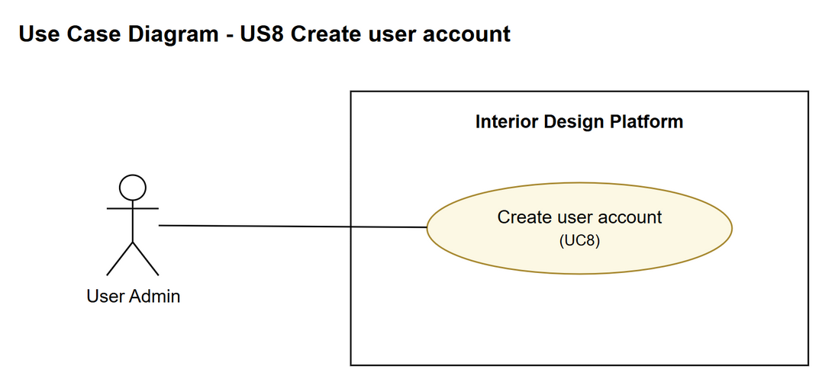
Figure 1: Use case diagram for US8 Create user account

3. Use case description
Use case | UC8 Create user account
Actor | User Admin
Brief description | The User Admin creates a new user account and puts it in a user profile, so a new user can log in.
User story | US8: As a user admin, I want to create a user account so that a new user can join the system.
Preconditions | The User Admin is logged in (UC1).  At least one active user profile exists (UC3).
Trigger | The User Admin clicks "Create user account" on the User Accounts page.
Basic flow | 1. The User Admin clicks "Create user account".  2. The system shows the create form.  3. The User Admin fills in the username, password, full name, email, phone, picks a user profile and clicks "Create".  4. The system checks that the required fields are filled in.  5. The system checks that the chosen profile is active and that the username isn't already used.  6. The system saves the new account with status Active. The password is saved as a hash.  7. The system shows "User account created successfully" and the updated list of accounts.
Alternative flows | 4a. A required field is empty: the system shows "Please fill in all required fields" and keeps what was typed. Back to step 3.  5a. The profile is suspended or the username is taken: the system shows "Invalid profile or username already exists" and nothing is saved. Back to step 3.
Postconditions | A new Active user account is saved in the chosen profile.  The new user can log in (UC1).

4. Wireframes
The wireframes were drawn in draw.io. They are low-fidelity: they show the layout and the flow, not the final colours. The orange numbers match the notes under each screen.

4a - Create user account form
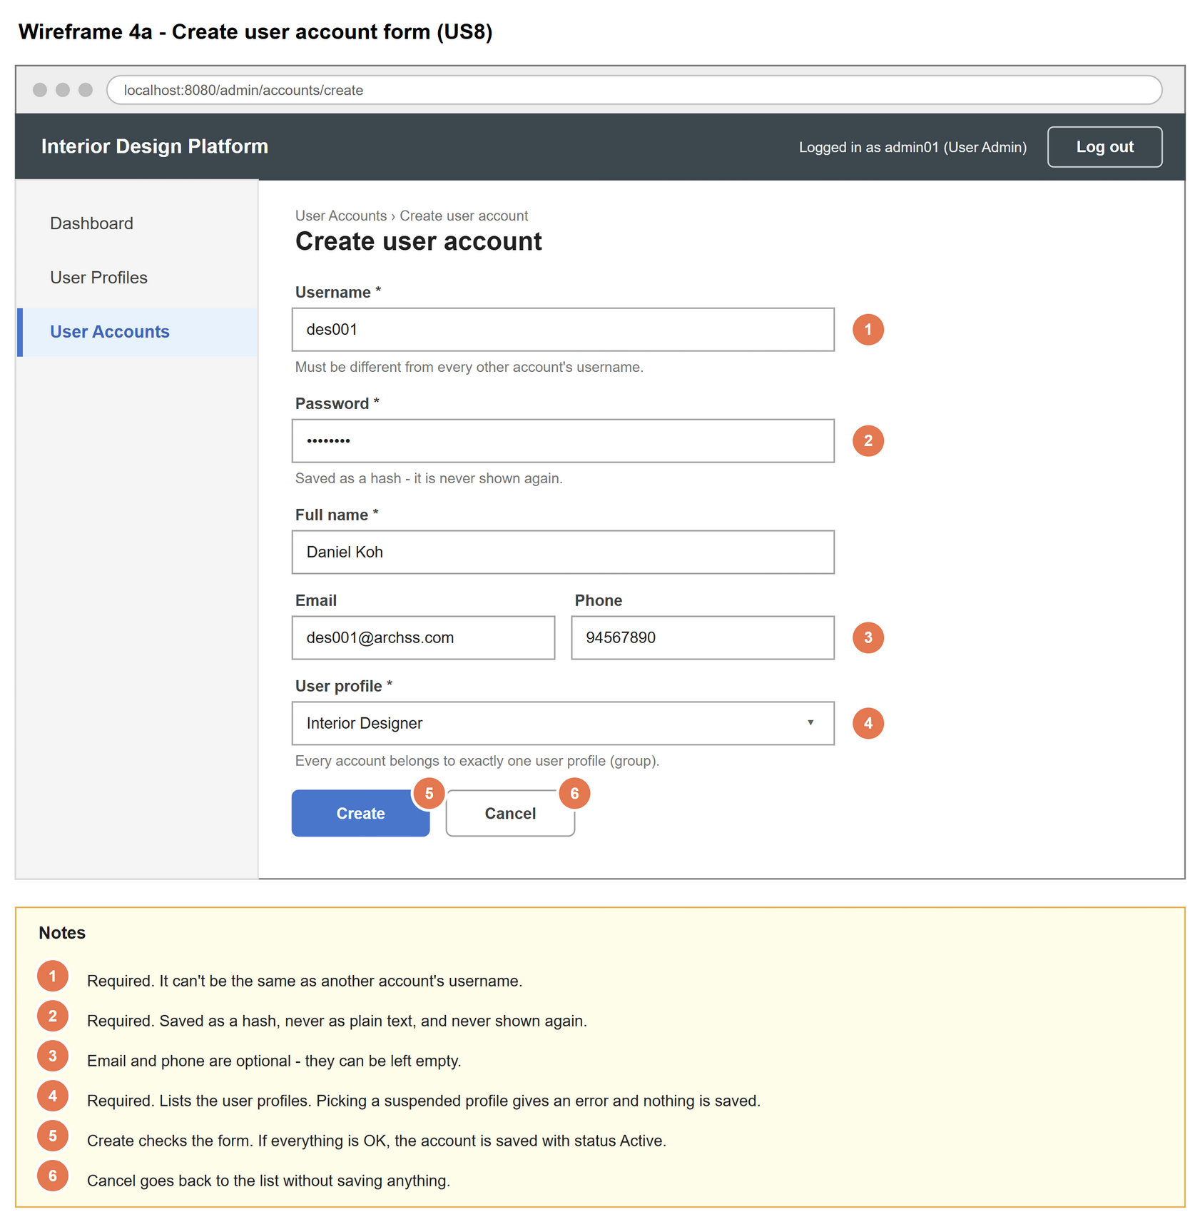
Figure 2: Wireframe 4a - Create user account form (US8)

4b - Create form errors
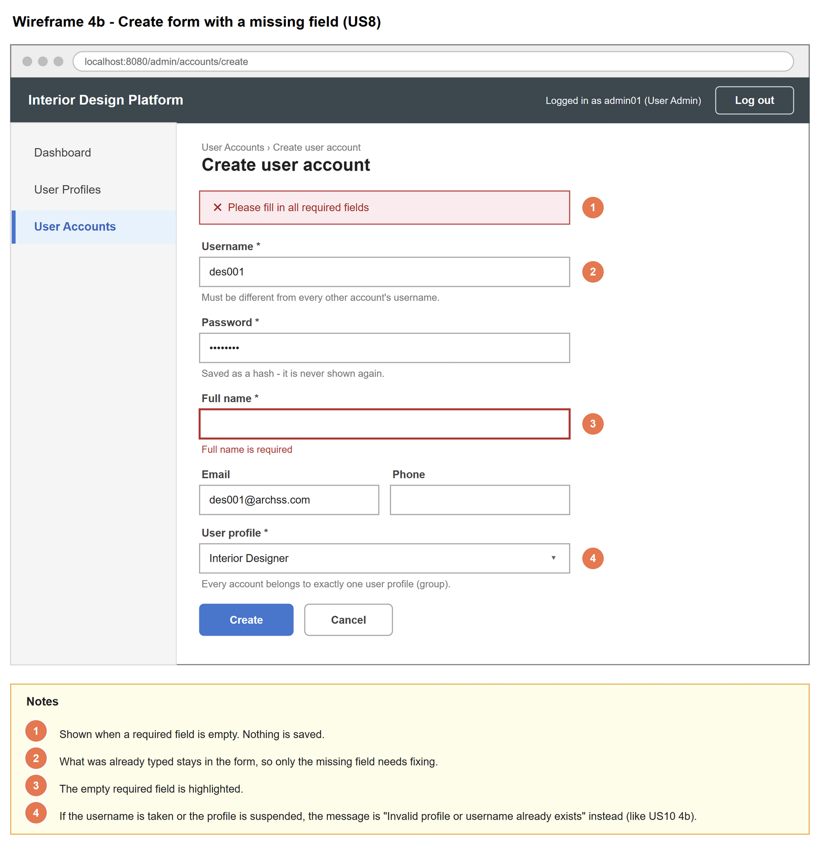
Figure 3: Wireframe 4b - Create form errors (US8)

4c - Account created
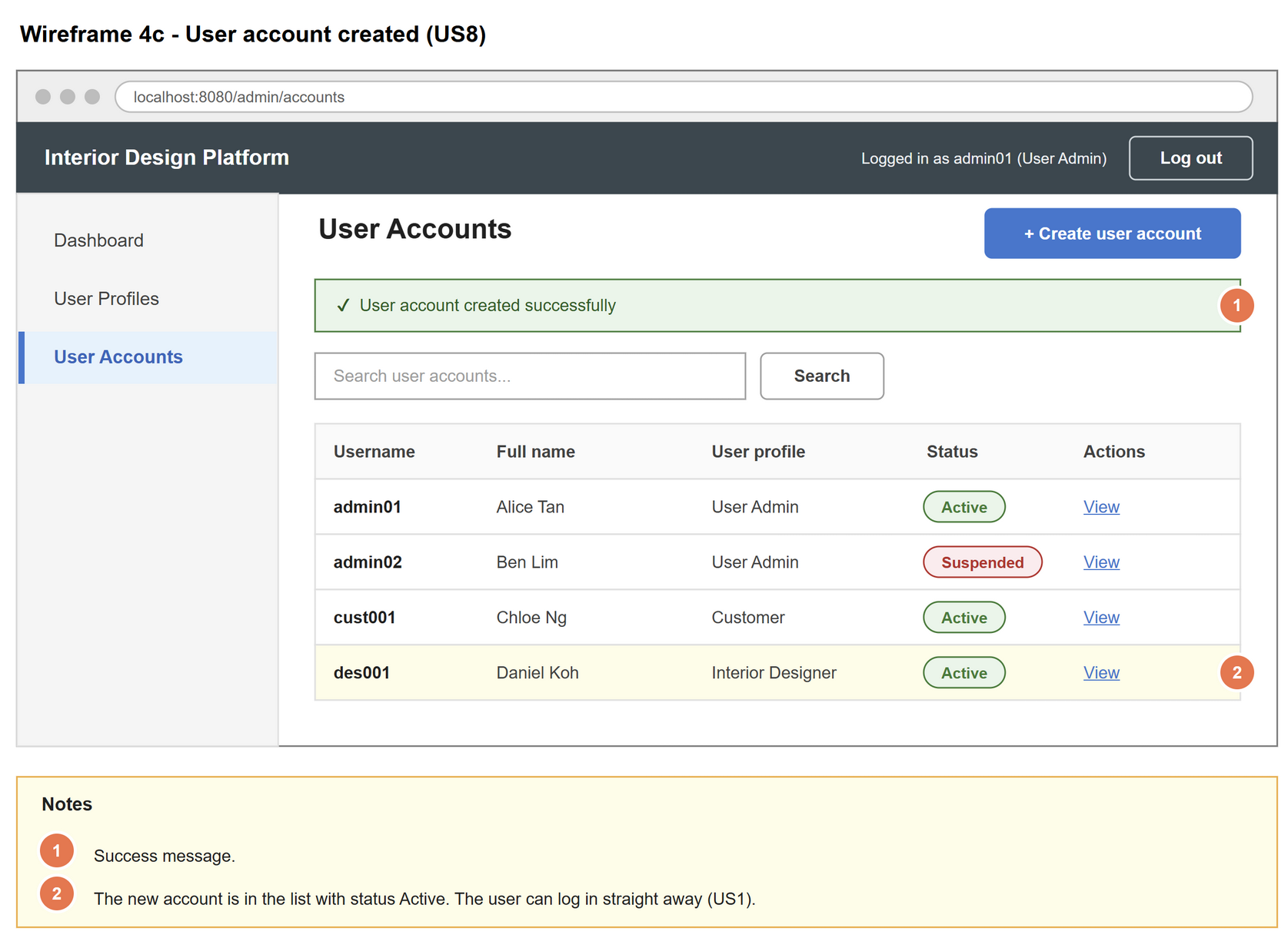
Figure 4: Wireframe 4c - Account created (US8)

5. B-C-E class diagram
The solid line means the boundary calls the controller. The dashed lines mean the controller uses the entity classes. Only the operations needed for this use case are shown.
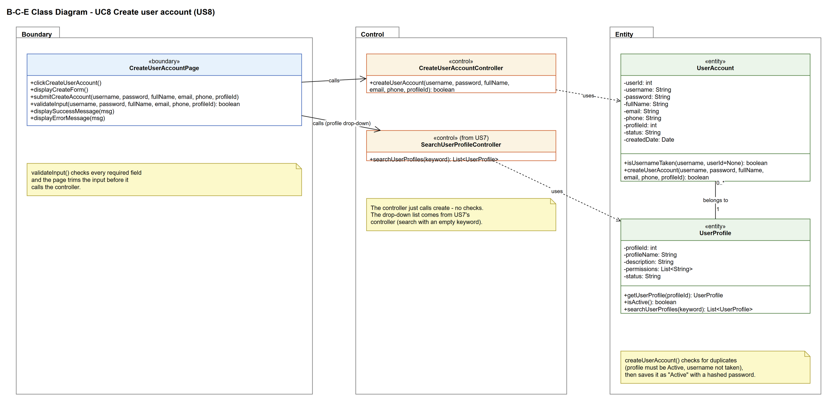
Figure 5: B-C-E class diagram for US8 Create user account
Layer | Class | What it does
Boundary | CreateUserAccountPage | The create form on the User Accounts page. Checks the required fields are filled in (validateInput), sends the details to the controller and shows the result.
Control | CreateUserAccountController | Controller for UC8. Applies the business rules: the profile must be active and the username must not be taken. Then asks UserAccount to save the new account.
Entity | UserAccount | The user account. isUsernameTaken() checks for duplicates and createUserAccount() saves the new row with a hashed password.
Entity | UserProfile | The group the account goes in (1 to 0..* relationship). getUserProfile() and isActive() make sure the account isn't put in a suspended group.

6. Sequence diagram
The sequence diagram follows UC8. The page shows the form (step 2) and checks the input when it is submitted (step 4). The outer alt splits valid input from a missing required field (alternative flow 4a). For valid input, the controller gets the chosen profile, checks it is active and checks the username isn't taken (step 5). Only if both are OK is the account saved (opt box, step 6). The inner alt shows the success message (step 7) or the error message (alternative flow 5a).
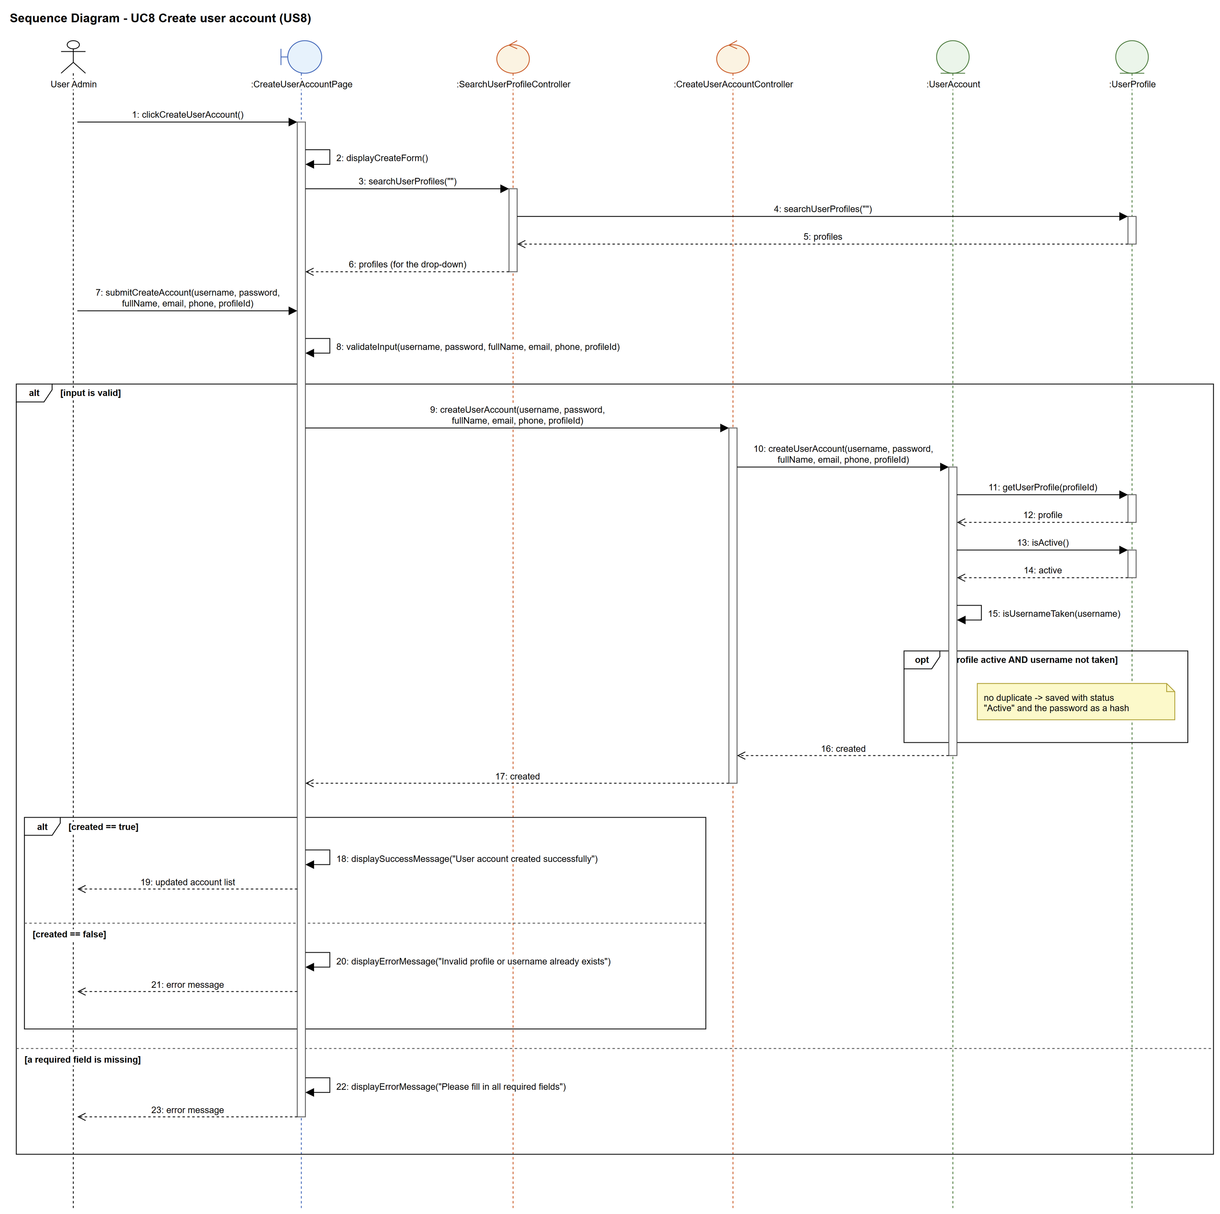
Figure 6: Sequence diagram for UC8 Create user account

7. Test cases
Test data used below (same as database/seedData.py): user profiles User Admin (id 1), Interior Designer (id 2), Customer (id 3) and Platform Manager (id 4), all Active. User accounts admin01 / Admin@123 (id 1, User Admin, Active), admin02 / Admin@123 (id 2, User Admin, Suspended) and cust001 / Cust@123 (id 3, Customer, Active).

7a. System test cases (black box)
Equivalence partitioning and boundary value analysis were used to pick the test data. Fill in "Actual result" and "Pass/Fail" after running each test.
Test ID | Scenario | Prerequisites | Test steps | Test data | Expected result | Actual result | Pass / Fail
TC8.1 | Create a valid account | Logged in as admin01. No account called des001. | 1. Click "Create user account"  2. Fill in the form  3. Click "Create" | des001 / Des@123, Daniel Koh, des001@archss.com, 94567890, Interior Designer | "User account created successfully". des001 is in the list with status Active.
TC8.2 | The new user can log in | TC8.1 done. | 1. Log out  2. Log in as des001 | des001 / Des@123 | des001 logs in normally.
TC8.3 | Optional fields left empty | Logged in as admin01. | 1. Click "Create user account"  2. Fill in only the required fields  3. Click "Create" | des002 / Des@123, Dana Lee, no email, no phone, Interior Designer | "User account created successfully".
TC8.4 | Required field missing | Logged in as admin01. | 1. Click "Create user account"  2. Leave username empty  3. Click "Create" | (empty) / Des@123, Daniel Koh, Interior Designer | "Please fill in all required fields". Nothing is saved.
TC8.5 | Username already taken | Logged in as admin01. | 1. Click "Create user account"  2. Fill in the form  3. Click "Create" | cust001 / Cust@123, Chris Ong, Customer | "Invalid profile or username already exists". There is still only one cust001.
TC8.6 | Suspended profile | Logged in as admin01. Platform Manager has been suspended (UC6). | 1. Click "Create user account"  2. Pick Platform Manager  3. Click "Create" | pm001 / Pm@123, Paul Goh, Platform Manager | "Invalid profile or username already exists". Nothing is saved.
TC8.7 | Password is not saved as plain text | TC8.1 done. | 1. Check the user_account table | des001 | The password column is a 64-character hash, not "Des@123".

7b. Unit test cases (for TDD)
These are written before the code (test-driven development) and run automatically in the CI pipeline. They cover normal inputs, abnormal inputs and boundary values.
Test ID | Class and method | Input / setup | Expected output | Type | Pass / Fail
UT8.1 | CreateUserAccountController.createUserAccount() | "des001", "Des@123", "Daniel Koh", "des001@archss.com", "94567890", 2 | Returns true. The new account has status "Active" and profileId 2. | Normal
UT8.2 | CreateUserAccountController.createUserAccount() | "cust001", ... , 3 (username taken) | Returns false | Abnormal
UT8.3 | CreateUserAccountController.createUserAccount() | "pm001", ... , 4 (Platform Manager suspended first) | Returns false | Abnormal
UT8.4 | CreateUserAccountController.createUserAccount() | "des001", ... , 9999 (no such profile) | Returns false (no error thrown) | Abnormal
UT8.5 | UserAccount.isUsernameTaken() | "admin01" | Returns true | Normal
UT8.6 | UserAccount.isUsernameTaken() | "nobody99" | Returns false | Normal
UT8.7 | CreateUserAccountPage.validateInput() | username "" (all other fields filled in) | Returns false | Boundary
UT8.8 | UserAccount.createUserAccount() | Same input as UT8.1 | The saved password equals hashPassword("Des@123"), not "Des@123" | Normal

